GIET ENGINEERING COLLEGE (AUTONOMOUS)
DEPARTMENT OF COMPUTER SCIENCE AND ENGINEERING
PROJECT DOCUMENTATION
ON
DARSHAN EASE
(Online Temple Darshan Booking System)
Submitted in partial fulfillment of the requirements for the

Skill Wallet Internship Program

Submitted By
KUMMARI SURESH

Technology Stack

MongoDB
Express.js
React.js
Node.js

Academic Year

CERTIFICATE
This is to certify that the project entitled "DARSHAN EASE – Online Temple Darshan Booking System" has been successfully completed by KUMMARI SURESH as part of the Skill Wallet Internship Program.
The project was developed using the MERN Stack (MongoDB, Express.js, React.js, and Node.js). The work carried out is original and has been completed under the prescribed internship guidelines.
This documentation is submitted as partial fulfillment of the internship requirements.

ACKNOWLEDGEMENT
I sincerely express my heartfelt gratitude to the Skill Wallet Internship Program for providing me with the opportunity to work on the project "Darshan Ease – Online Temple Darshan Booking System." This internship has given me practical exposure to Full Stack Web Development using the MERN Stack.
I would like to thank the faculty members of GIET Engineering College (Autonomous) for their continuous encouragement, guidance, and valuable support throughout the internship.
I also extend my gratitude to my mentors and everyone who directly or indirectly contributed to the successful completion of this project.
This project has enhanced my knowledge of MongoDB, Express.js, React.js, Node.js, REST APIs, GitHub, and modern web application development. It has helped me improve my technical skills, problem-solving ability, and confidence in developing full-stack applications.
Finally, I thank my parents, friends, and well-wishers for their constant support and motivation throughout the completion of this project.
Signature
KUMMARI SURESH

ABSTRACT
The Darshan Ease project is a full-stack web application developed using the MERN Stack (MongoDB, Express.js, React.js, and Node.js). The main objective of this project is to provide an efficient and user-friendly online temple darshan booking system that reduces waiting time and simplifies the booking process.
The application allows users to view temple information, select a preferred darshan date and time slot, enter personal details, and confirm their booking. Users can also view their booking history through the application. An Admin Login module is provided to manage and monitor the system.
The frontend of the application is developed using React.js, providing a responsive and interactive user interface. The backend is built with Node.js and Express.js, which handle API requests and business logic. MongoDB is used as the database to store booking information securely.
This project demonstrates the practical implementation of full-stack web development concepts, including REST APIs, database connectivity, routing, and frontend-backend integration. It improves user convenience, minimizes manual work, and provides a modern digital solution for temple darshan management.

INTRODUCTION
The Darshan Ease project is a web-based application developed using the MERN Stack (MongoDB, Express.js, React.js, and Node.js). It is designed to provide an easy and efficient way for devotees to book temple darshan tickets online without visiting the temple in person.
In many temples, the traditional booking process involves standing in long queues, filling out forms manually, and waiting for confirmation. This process consumes time and can be inconvenient, especially during festivals and holidays. The Darshan Ease system solves these problems by providing a simple online platform where users can register, choose a preferred darshan date and time, and book their slots from anywhere.
The application provides a user-friendly interface that allows users to enter their details, confirm bookings, and view their booking history. The system also includes an Admin Login module for managing the application. The backend communicates with the MongoDB database through RESTful APIs to securely store and retrieve booking information.
The project demonstrates the practical implementation of full-stack web development concepts such as frontend development, backend development, database management, API integration, and responsive web design. It is developed to improve efficiency, reduce manual work, and provide a better experience for temple visitors.

PROJECT OVERVIEW
Darshan Ease is an online temple darshan booking system developed using the MERN Stack. The project provides a simple and secure platform for devotees to book darshan slots online. It reduces manual work, avoids long waiting queues, and improves the overall booking experience.
Key Features
User-friendly Home Page
Admin Login
Online Darshan Booking
View Bookings
Responsive User Interface
REST API Integration
MongoDB Database Storage
Secure Data Management
Fast Booking Process

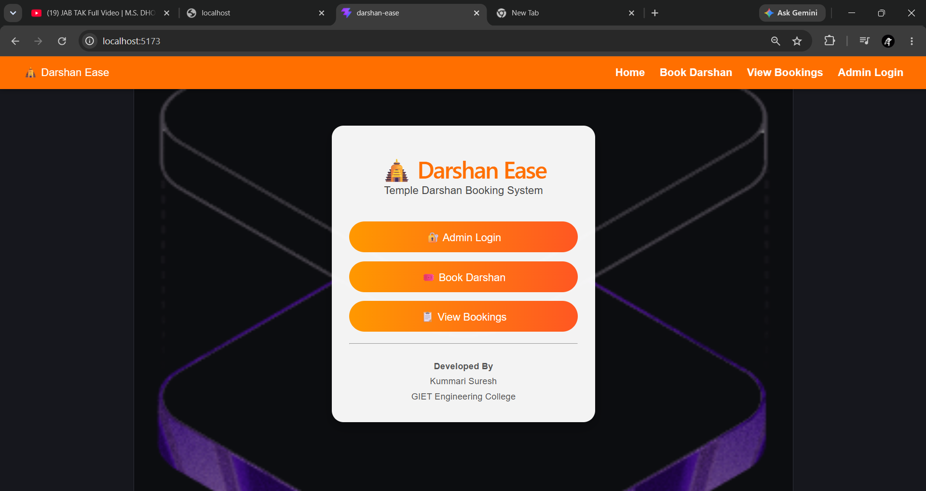

FOLDER STRUCTURE
The Darshan Ease project follows a structured MERN architecture by separating the frontend and backend into different folders. This organization makes the application easier to develop, test, and maintain.
darshan-ease/
│
├── client/
│ ├── public/
│ ├── src/
│ │ ├── pages/
│ │ ├── assets/
│ │ ├── App.jsx
│ │ └── main.jsx
│ ├── package.json
│ └── vite.config.js
│
├── server/
│ ├── server.js
│ ├── package.json
│ └── node_modules/
│
└── README.md

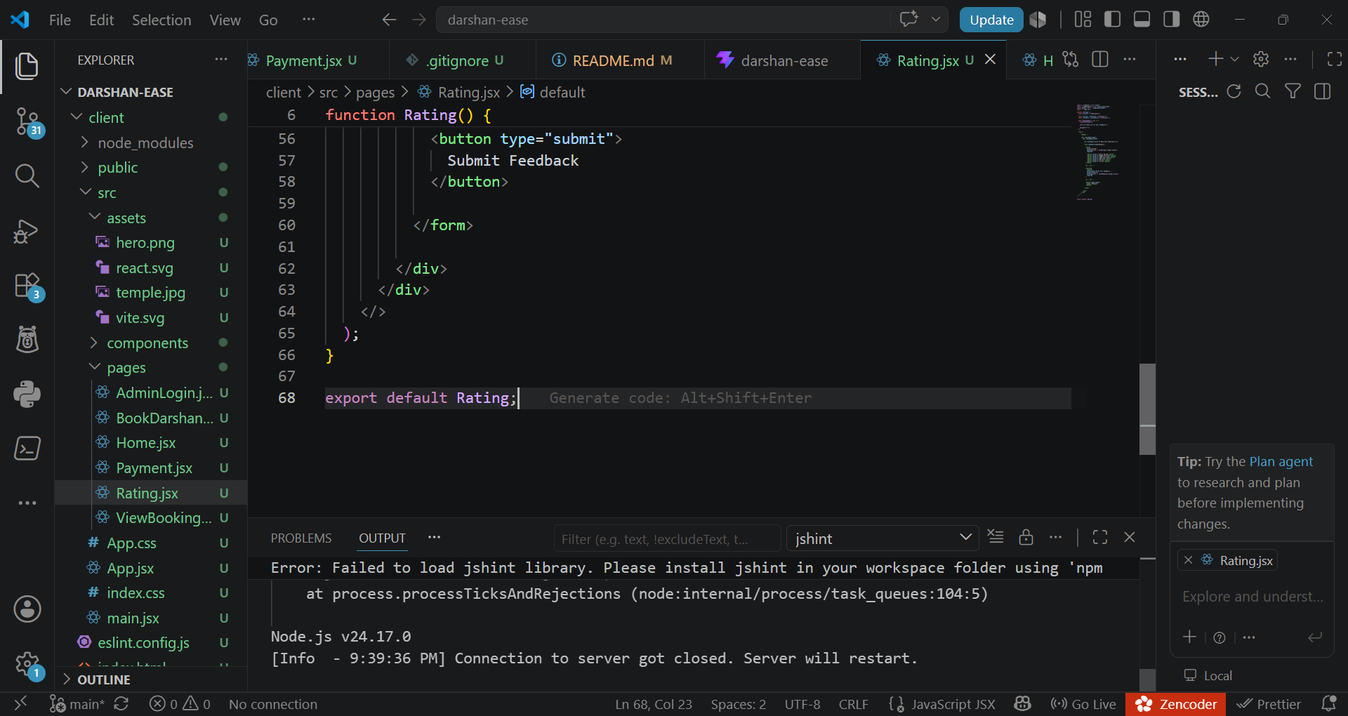

API DOCUMENTATION
METHOD | ENDPOINT | DESCRIPTION
GET | / | Backend server running
POST | /api/booking | Create a new booking
GET | /api/bppking | View all booking
The Darshan Ease application uses REST APIs to enable communication between the React frontend and the Node.js backend. The APIs are responsible for creating bookings and retrieving booking information stored in MongoDB.
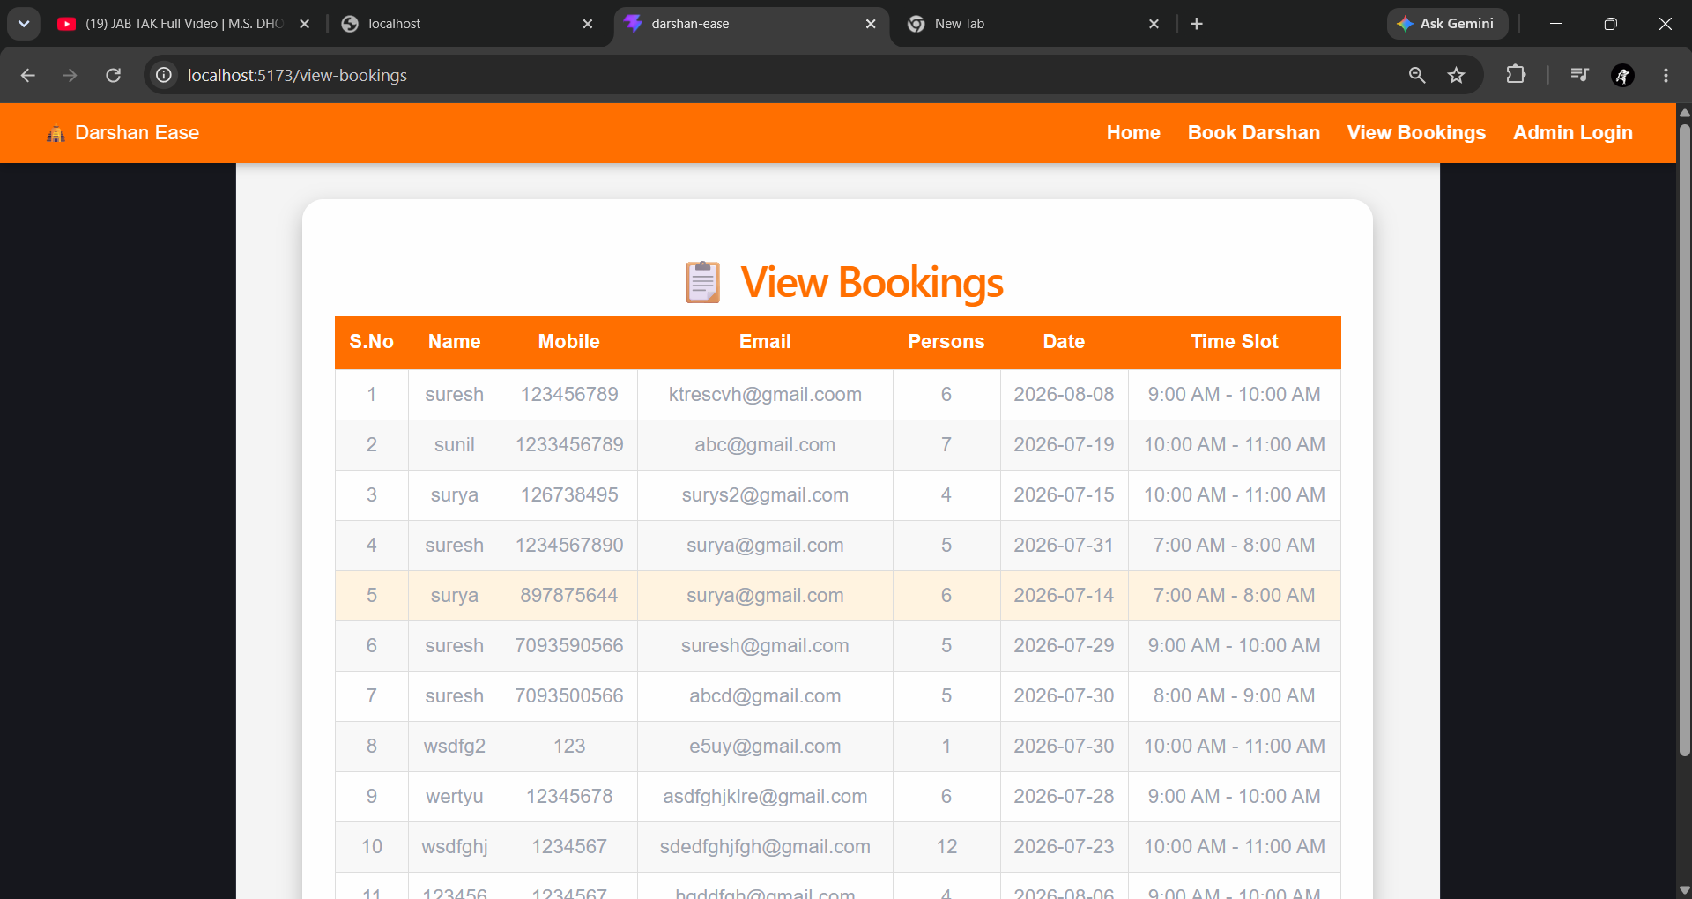

BOOK DARSHAN MODULE
Description
The Book Darshan module allows users to reserve a temple darshan slot online. Users enter their personal details, select the number of persons, choose a preferred date, and select a time slot. After submitting the form, the booking details are sent to the backend using a REST API and stored in the MongoDB database.
Features
User-friendly booking form
Name, Mobile and Email fields
Select date and time slot
Number of persons
Submit booking
Data stored in MongoDB
Success confirmation

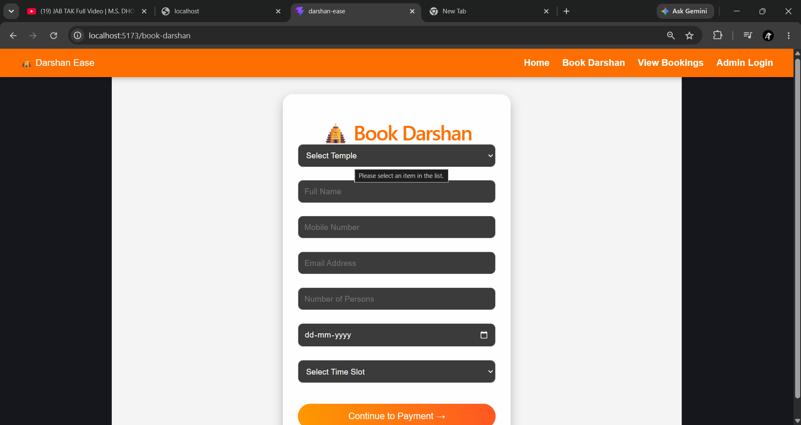

ADMIN LOGIN MODULE
The Admin Login module provides secure access for administrators to manage the Darshan Ease application. The administrator can log in using valid credentials and monitor the booking system.
Features
Secure login page
Username and password authentication
Easy navigation
Access to booking management
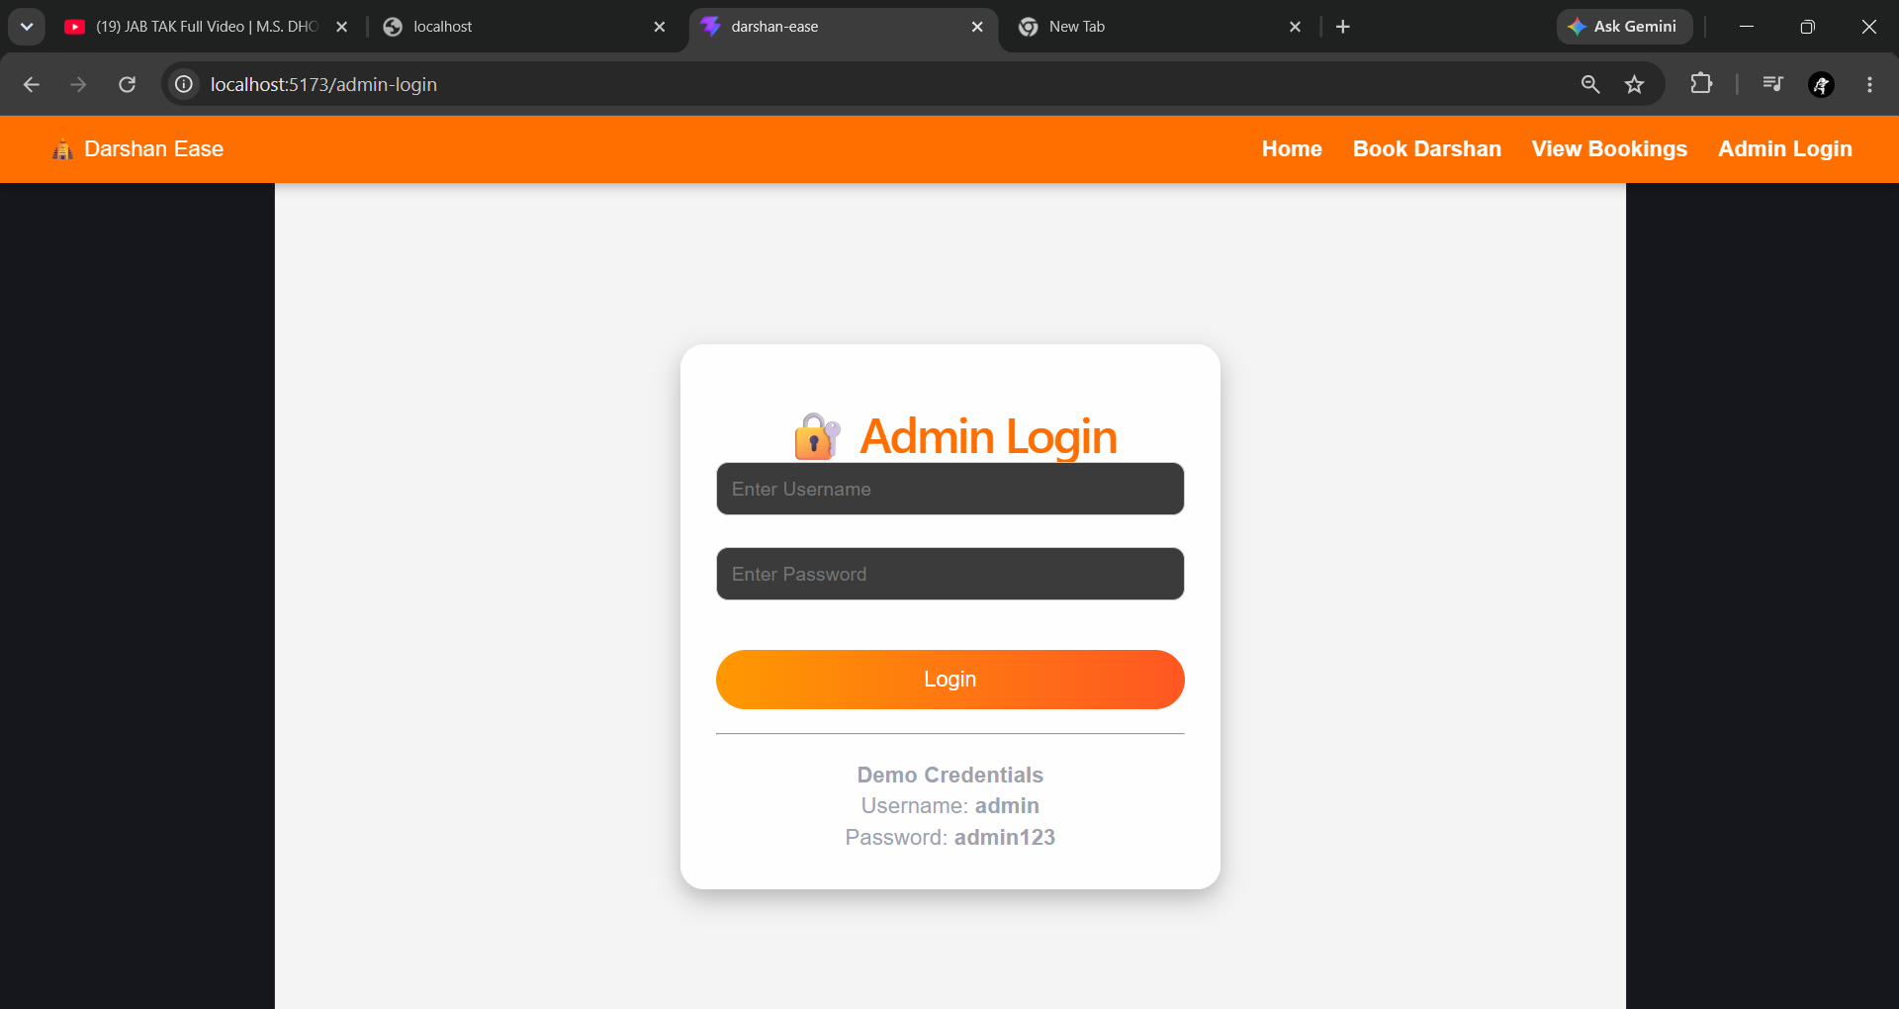

TESTING
Testing is an essential phase of software development that ensures the application works correctly and meets user requirements. The Darshan Ease project was thoroughly tested to verify the functionality of all modules, including the Home Page, Book Darshan, View Bookings, and Admin Login. Each feature was tested individually to ensure that it performed as expected without errors.
During testing, users were able to successfully access the application, submit darshan booking requests, and view booking details stored in the MongoDB database. The communication between the React frontend and the Node.js backend was verified through REST APIs, and all booking data was stored and retrieved successfully. The application also displayed a responsive and user-friendly interface across different pages.


The above screenshot shows the successful execution of the View Bookings module. It displays the booking details entered by users, including name, mobile number, email, number of persons, booking date, and time slot. The data is retrieved from the backend and displayed successfully, confirming that the frontend, backend, and database are integrated correctly.

DEPLOYMET/PROJECT EXECUTION
Deployment / Project Execution:
The DarshanEase application was successfully executed using the MERN stack. The frontend React application runs on the Vite development server, and the backend Node.js + Express.js server handles API requests. MongoDB is used for storing booking data. The complete application flow, including temple exploration, darshan booking, and viewing bookings, was tested successfully.
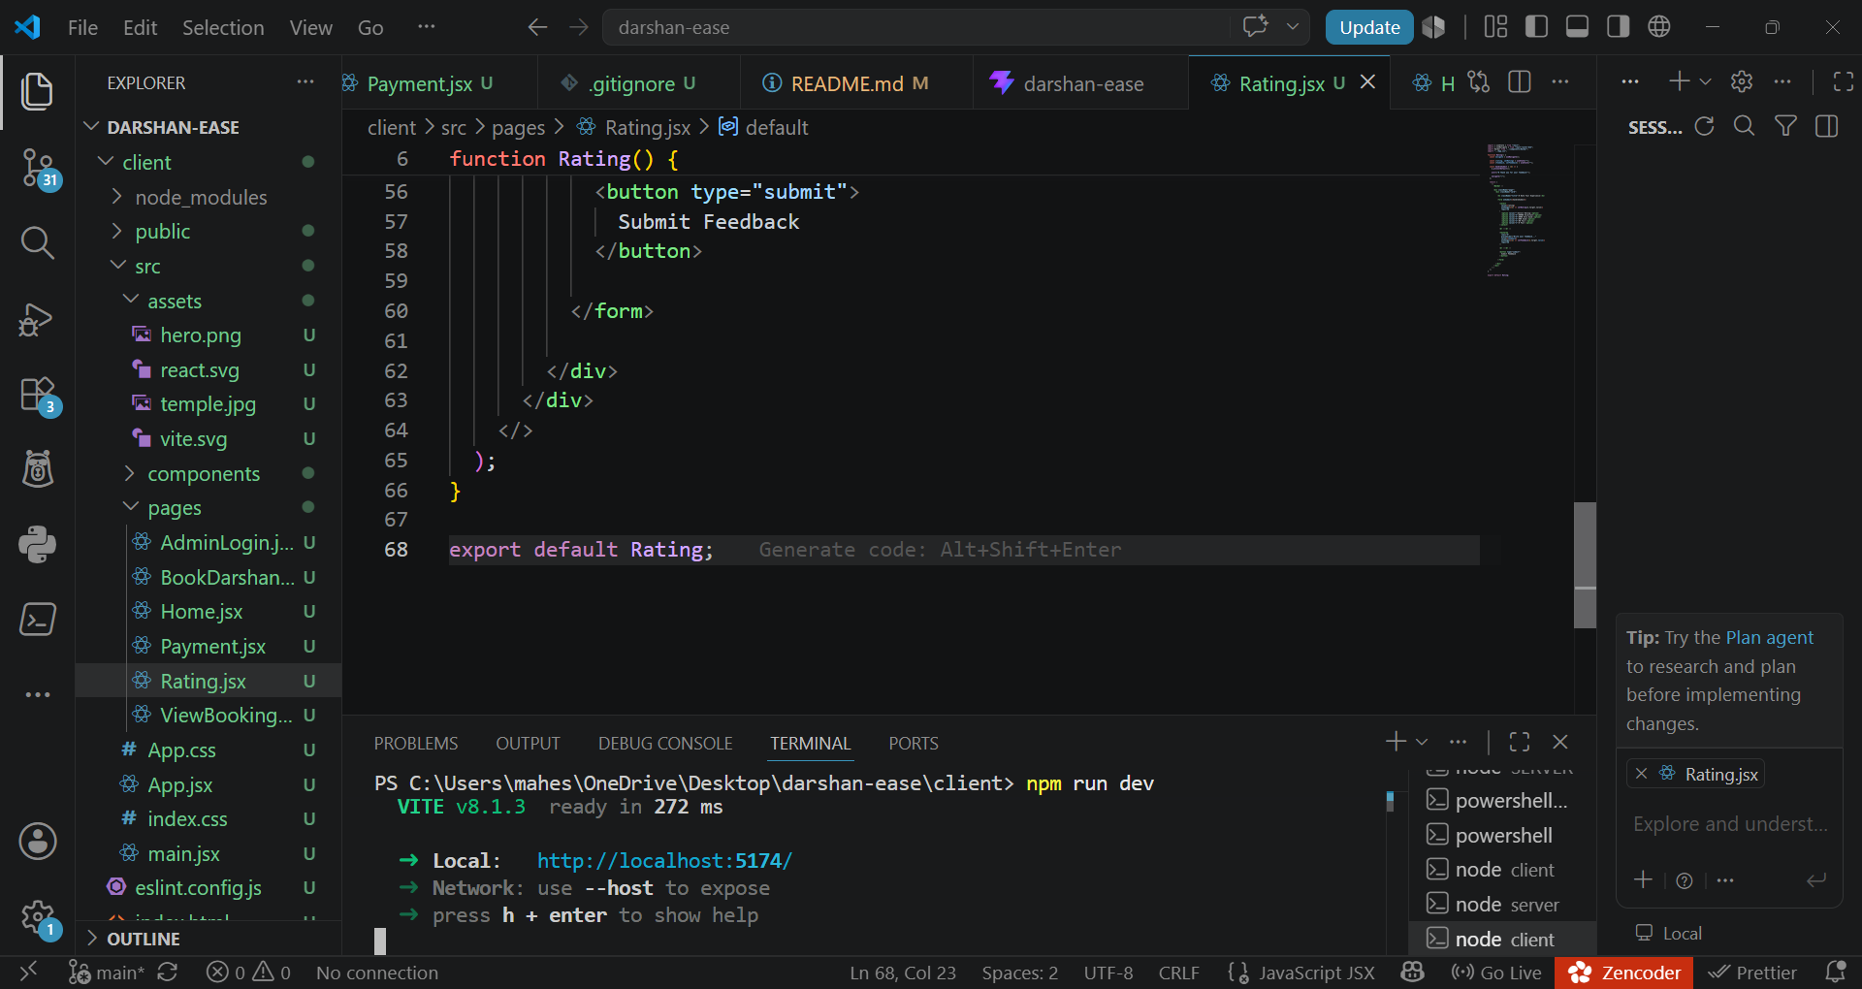

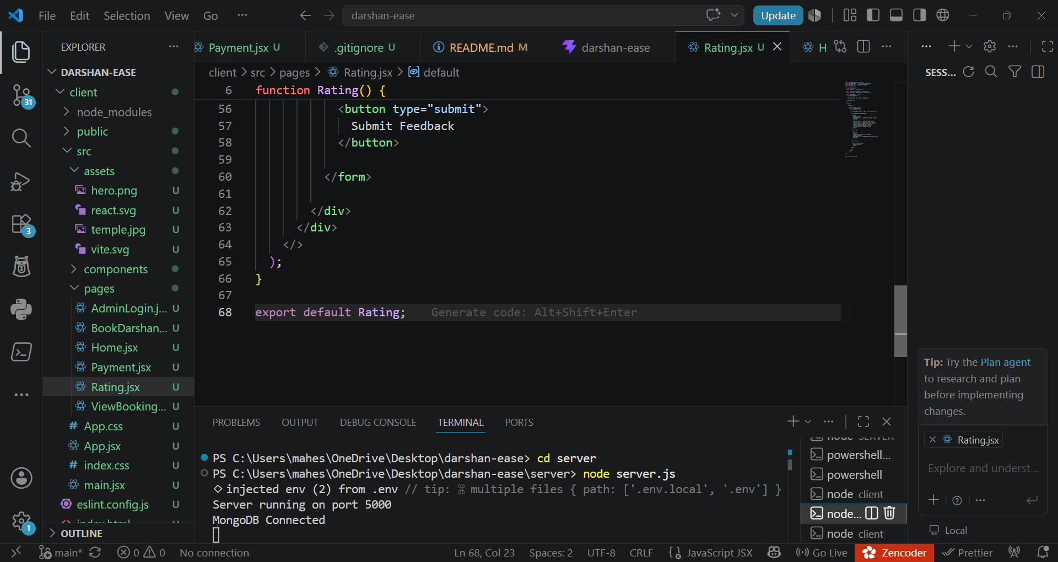

CONCLUSION
DarshanEase is a full-stack MERN web application developed to simplify the temple darshan booking process. The system allows users to view temple details, select available darshan slots, and book tickets online. The application uses React.js for the frontend, Node.js and Express.js for backend services, and MongoDB for database management. The project successfully demonstrates the use of modern web technologies to create a user-friendly and efficient online booking platform.

